1. Why do we need a seed to create an account? How does that seed look like?

It is a list of words which store all the information needed to recover a Bitcoin wallet. If the user’s computer breaks or their hard drive becomes corrupted, they can download the same wallet software again and use the paper backup to get their bitcoins back.

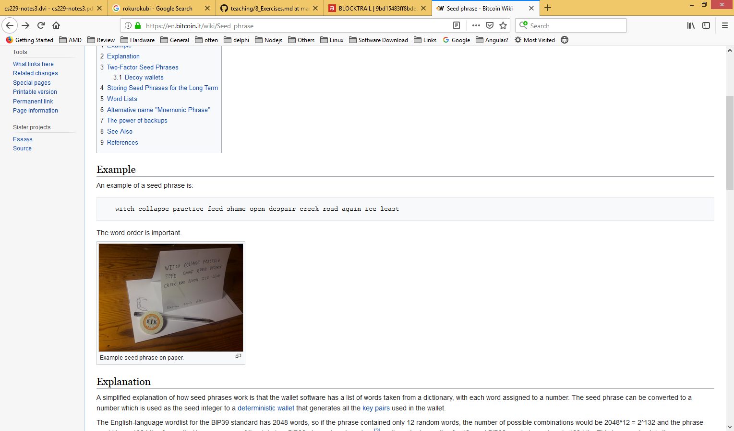

Concert warfare swift amount aisle genuine leave swim mom tomorrow betray candy

*From Bitcoin Wiki*

1. What does it mean by “confirmations” when you send and receive coins?

After a transaction is broadcast to the Bitcoin network, it may be included in a block that is published to the network. When that happens it is said that the transaction has been mined at a depth of 1 block. With each subsequent block that is found, the number of blocks deep is increased by one. To be secure against double spending, a transaction should not be considered as **confirmed** until it is a certain number of blocks deep.

1. How do transactions look like? What is an input? What is an output?

*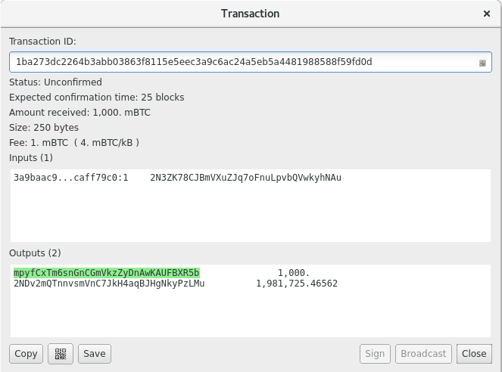taken from Faucet:*

Inputs are 3a…Au, a public key address

Outputs are mp…5b, my public key address and 2ND… as part of the change.

1. Is the total amount of coins transacted in a transaction the same amount that you receive? Why? What is an input? What is an output?

No. There was more than one output because I didn’t have any previous transactions that added up the exact amount of the transaction.

So the client picked up some coins that added to at least that amount and then created a new address to receive the left over amount. So 2ND … is me as well.

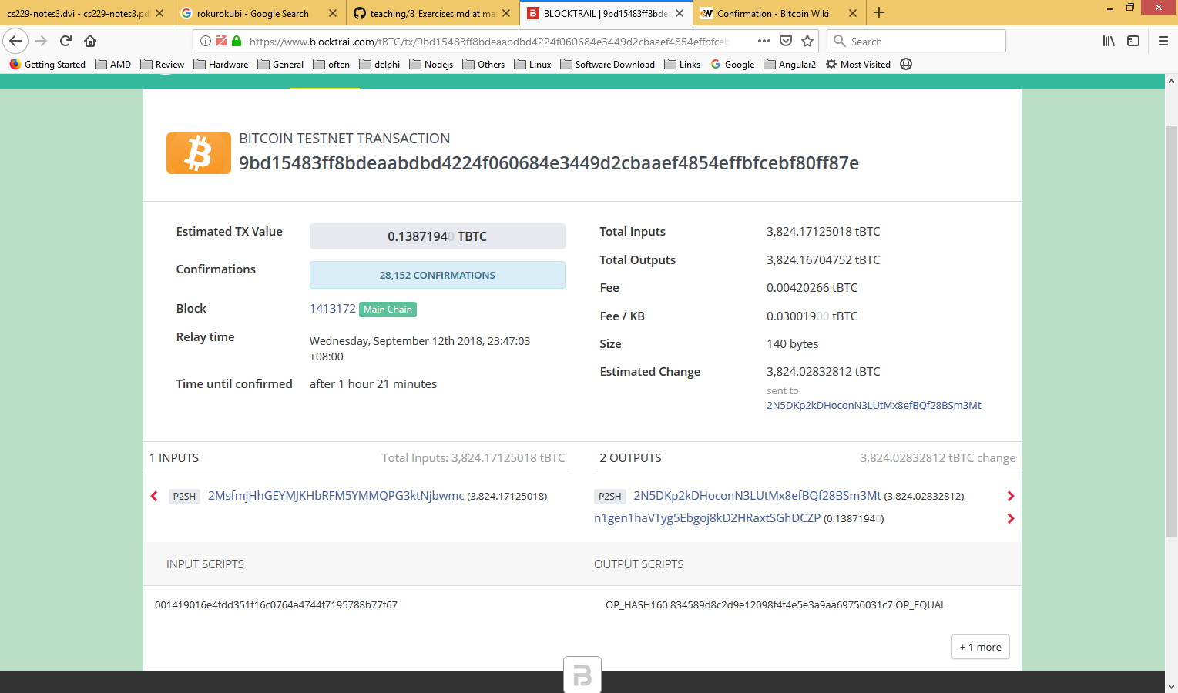

1. What is the total amount transacted?

0.1387194 TBTC

2. What are the receiving addresses?

2N5DKp2kDHoconN3LUtMx8efBQf28BSm3Mt

n1gen1haVTyg5Ebgoj8kD2HRaxtSGhDCZP

3. When did it happen?

September 12th 2018

4.. Now check transaction ID **27eb699a9ab24876858bd29c42f3831f036a57c72a3dc701c187d196291afbc8**, is it different?

Second transaction involves multiple signatures, therefore this second account is from a multisignature wallet.

